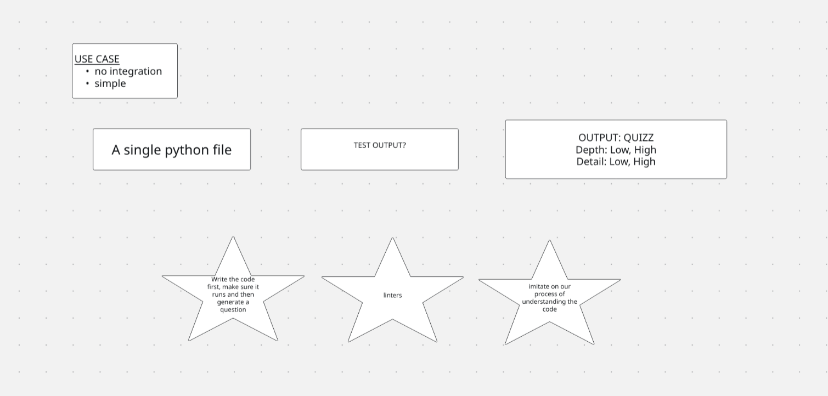

GOAL: create quizzes about a python file to check our understanding of the code and its internal organization.

Input: a python program

Output: it should create a quiz that has a mix of low and high levels of depth and detail. The combination are valid:

- Low depth, low detail
- Low depth, high detail
- High depth, high detail
- High depth low detail

Steps:
- LLM should understand the content of the file
- LLM should cover the key classes, structures, functions that inside of it
- LLM should provide the user with the correct answer
- Any time a question regarding an executable part of the code is created, the code should be run and executed first to ensure validity of the answer
- If the code has a clear or obvious error, you are also allowed to give it to the user
- Linters should be used to create questions regarding code improvements

Design and execution:
- Create a html quarto presentation with the question, code and a hidden answer in the following slide
- Execution should be done via a python module, i.e. `python codecheck script.py -n quiz1` should generate a html of quiz1. If no name is given, a random unique identifier will be generated for that file.

Tech Stack:
- OpenAI
- Quarto
- Python 3.8+
- Pytest
- No vectorstores

